Summary of research findings

I would like to thank everyone who took part in the ‘motor skills’ study, and in the ‘spatial skills’ study. The results of both studies were collected at the same time and involved individuals with Williams Syndrome (a rare genetic disorder), and typically developing children aged 4-7 years, recruited from two London primary schools. Below is a summary of our findings.

Study 1: Motor abilities and physical activity

This study investigated fine motor (e.g. drawing, writing, using cutlery, etc) and gross motor (e.g. walking, running, balancing, etc) abilities in people with Williams Syndrome and in typically developing children. We also asked participants about their participation in physical activity. This research is important because individuals with Williams Syndrome have real problems with their motor skills, such as climbing stairs, getting dressed and writing among others. However, there has been little research investigating this, or the specific strengths and weaknesses in the Williams Syndrome motor profile. Although we were working with adults with Williams Syndrome, it was also important that we worked with typically developing children between the ages of 4 and 7, as this is the average level of motor ability for adults with Williams Syndrome.
Previous research has found a positive link between participation in physical activity and motor skills in typically developing children and adults, and so we wanted to see if this was also the case for individuals with Williams syndrome. Knowing more about the motor profile and the participation in sports and exercise in these individuals will aid in our understanding of the syndrome, and help us to design effective interventions in the future.

The study included four fine motor tasks, such as tasks of drawing, folding and a task where participants were asked to manipulate small objects; and nine gross motor tasks, which included tasks such as hopping, walking on a line, dribbling a tennis ball, balancing and push-ups. All participants were also given a questionnaire regarding their level of physical activity. In this questionnaire, they were asked, in a typical week, how many times during weekdays they participated in sports (excluding P.E.), how many times during the weekend they participated in sports, and whether they enjoyed taking part in sports.

Results

We found that, in typical development, unsurprisingly, children’s motor abilities got better between the ages of 4 and 7. The amount of physical activity also increased with age in typical development, which may be due to older children having more independence and motivation to take part in sports outside of the home. There was also a positive correlation between the amount of physical activity and motor score, with children who took part in more sports tending to have higher motor scores.

In general, individuals with Williams Syndrome performed to around the same level of motor ability as a typical 4-5-year-old, which suggests severe deficits in the motor abilities of these individuals. This may be due to several factors, such as lack of independence leading to less opportunity to practice motor skills, differences in the structure and function of several brain areas responsible for motor function, cardiovascular difficulties, and problems with muscles and joints in this population. It was also found that individuals with Williams Syndrome, on average, took part in a similar amount of sports as the 4-5-year-old children, and significantly less than the 6-7-year-olds. There was, however, still a positive correlation between the amount of physical activity and the motor ability in Williams Syndrome also, which suggests possible methods of intervention, which could be investigated in more detail in the future.

Study 2: How do small scale spatial skills relate to motor ability?

This study looked at the potential relationship between small scale spatial skills, both with and without a motor element, and how this related to motor skills in individuals with Williams Syndrome and typically developing children. Previous research has found that small scale spatial skills, such as mental rotation (forming an image in your head of an image, and rotating it), are significantly associated with motor skills in infancy, childhood and into adulthood. However, it is not yet known what the association is between small scale spatial skills and motor ability in Williams Syndrome. This is particularly important to determine because both spatial abilities and motor abilities are impaired in Williams syndrome and so an intervention in one domain could impact the development of the other. Examples of the small-scale tasks can be seen below:

Block construction

Participants were given a 2D image (e.g. b), and asked to construct a 3D model using identical plastic blocks, in the grid (a). The patterns increased in difficulty from two patterns made using two blocks, nine patterns made from four blocks, and finally two patterns made from nine blocks. Participants were also given a non-manual block design task where the experimenter manipulated the blocks for the participant. That is, participants were shown a numbered grid (a) and asked which of the block faces (c) should go in each segment of the grid to complete the pattern (b).

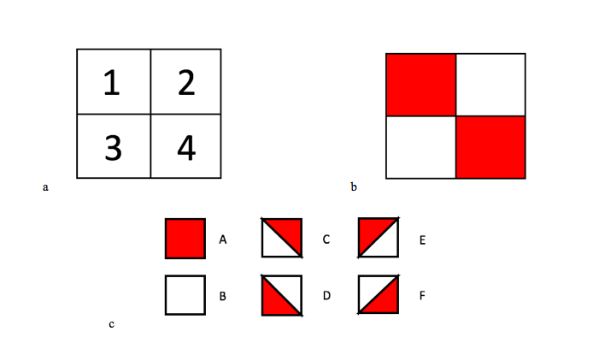
“Look at these blocks, they are all the same. On some sides they are all red, on some they are all white, and on some they are red and white. I want you to use these blocks to make these pictures (b) in this grid (a)”

“Now we are going to do something a bit different. In this game, I want you to tell me which letter block (c) goes in the grid (a) to make the pattern (b)”

Mental rotation

In this study, the participants were given two mental rotation tasks, one where they were asked to mentally rotate a picture of a chicken, and another where they were asked to mentally rotate a picture of a jug, and match the rotated image to one of two non-rotated images (either a match or a mirror image). This is because previous brain imaging research has shown that when people are asked to mentally rotate a picture of a tool (something you manipulate with your hands, here the jug), they use more motor brain areas to complete the task than when they are asked to rotate pictures of animals.

a. 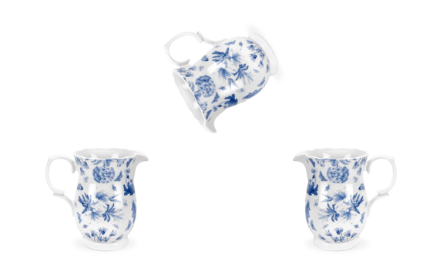 b. 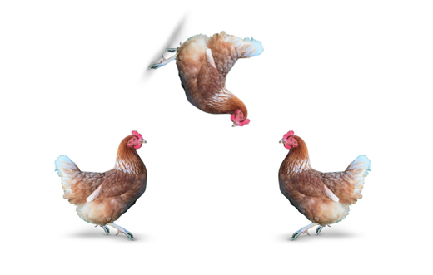

“Look at these pictures. I want you to imagine that the jug/chicken on the top is standing the right way up, and then tell me which one it matches at the bottom. Which one is facing/going the same way?”

Results

Both the Williams Syndrome and typically developing groups found the manual block design task easier (where they were asked to move the blocks themselves), which could be due to participants finding the manual block design task more fun and engaging, which was certainly the case when participants were asked which task they preferred. As in the motor tasks, the Williams Syndrome group performed to the same level, on average, as the typically developing 4-5-year olds. The performance on both block construction tasks increased with age, with the 6-7 year olds performing better than the 4-5 year olds. There were also positive correlations between both fine and gross motor ability and performance on the manual and non-manual block construction tasks, meaning that better performance on the motor tasks was associated with better performance on the block tasks.

Developmental changes were observed in both the mental rotation of tools and animals in the typically developing groups, with the 6-7 year olds performing more favourably than the 4-5 year olds, alongside the anticipated deficits in the mental rotation abilities in the Williams Syndrome group, who performed at the 4-5-year old level. There were also positive correlations between both fine and gross motor abilities and performance on both the jug and chicken mental rotation task, with better motor skills correlating with increased accuracy and faster reaction times on the mental rotation tasks.

To see more results from our lab, please visit: http://cogdevlab.weebly.com/ and follow the ‘For Parents’ link.

Thank you all again!

Leighanne Amy Mayall (PhD Student)

Email: leighanne.mayall.14@ucl.ac.uk

